

Topic test 2
Name: __________________________________

Chapter 7: Rates of change

• Time allowed: 45 minutes
• CAS calculators may be used.
• Part A: 5 multiple-choice questions (5 marks)
• Part B: 5 short answer questions (22 marks)
• Part C: 2 analysis questions (14 marks)
Part A
5 multiple-choice questions
1 mark each: 5 marks
Circle the correct answer.
1 This graph shows the height of a railway line as you move 50 km down the track from one station to another. The heights are normal heights above sea level.
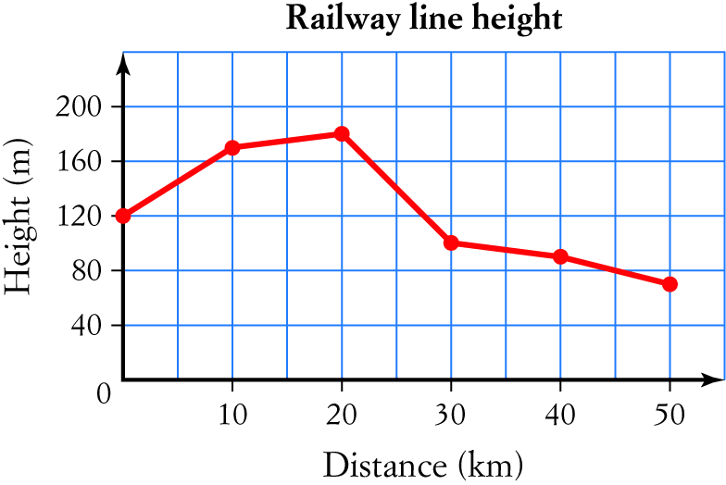
The average rate of change for the height of the track between the two stations is:
A −4.2 m/km
B −1.6 m/km
C 4.2 m/km
D −3 m/km
E −5 m/km

[1 mark]
2 From the graph in question 1 the instantaneous rate of height change at a distance of 10 km from the second station was:
A 4 m/km
B 1.6 m/km
C 8 m/km
D 3 m/km
E 5 m/km

[1 mark]
3 An experienced skydiver had reached a speed of 42 m/s when she deployed her parachute. 0.5 seconds later, her speed had dropped to 38 m/s and she had fallen 20 m. If she continued to change her speed at the same rate, how long would it be after opening the chute before she reached a safe landing speed (for her) of 6 m/s?
A 8 s
B 5.25 s
C 4.75 s
D 4.5 s
E 4 s

[1 mark]
4 The graph below shows the graph of a function.
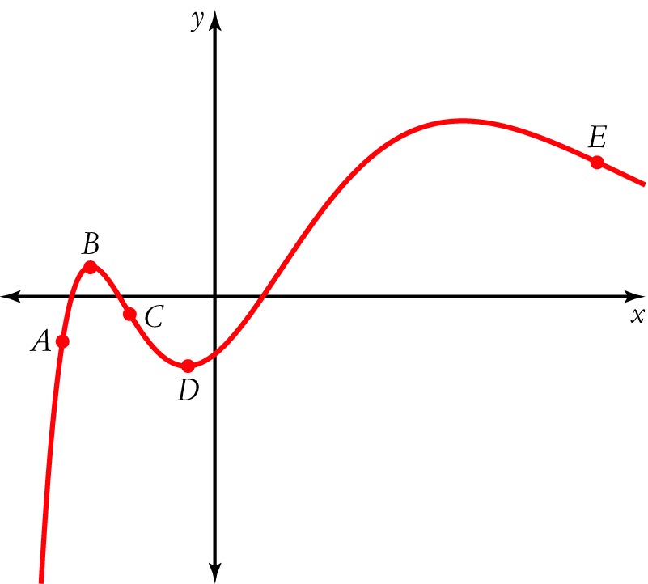
At which point(s) on the graph is the rate of change the smallest?

[1 mark]
5 The rate of change of f(x) = 3x2 − x3 − 4 at x = 3 is approximately:
A 9
B −9
C 13
D −13
E −24

[1 mark]
Part B
5 short answer questions
22 marks
Show your working where appropriate.
1 A tyre was badly under-inflated, with a pressure of only 100 kPa. After inflation, the pressure rose to 200 kPa in the first 3 seconds and then to 280 kPa after a further 2 seconds. What was the average rate of change of inflation pressure?

[2 marks]
2 The graph below shows the temperature of a cup of black espresso coffee during the first 10 minutes after it was poured. Find the average rate of temperature change between 1 and 4 minutes after it was poured.
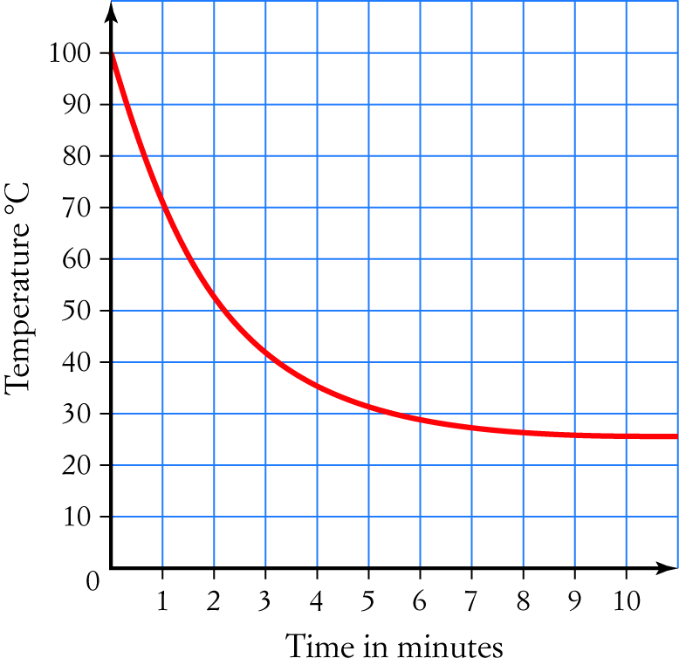

[4 marks]
3 Use a tangent on the graph in question 2 to find the rate of change for the temperature 3 minutes after the cup of coffee was poured.

[7 marks]
4 Find the gradient of f(x) = 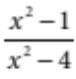 at x = 3 using a tangent (on your CAS calculator).

[4 marks]
5 Use δx = 0.04 to find the approximate gradient of y = 2x − x2 + 5 at x = 3 using a secant around the point.

[5 marks]
Part C
2 analysis questions
14 marks
Show your working where appropriate.
1 Find approximate rates of change for the function f(x) = 3x2 − 4x +1 at values of x from 0 to 4 to suggest a function for its rate of change.

[7 marks]

2 a Find the approximate rates of change for the function f(x) = 20x at values of x = 0, 2 and 3.

b By considering the ratios of the rates of change for f(x) to the function values at 0, 2 and 3, suggest a function for the rate of change of f(x)

[7 marks]
Total marks: 41

Answers
Part A [1 mark each]
1 Average rate of change = 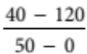 = −1.6 m/km
B [1 mark]
2 The line at 40 km passes through (30, 100) and (50, 40), so the rate of change
= 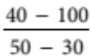 = −3 m/km
D [1 mark]
3 Rate of change of speed = 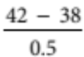 = −8 m/s/s
Desired change of speed = 6 − 42 = −36 m/s
Time for change = 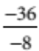 = 4.5 s
D [1 mark]
4 The smallest rate of change is where the graph is steepest going down.
C [1 mark]
5 Choosing δx = 0.2, rate of change  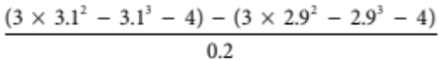 = −9.01
B [1 mark]
Part B
1 Average rate of pressure change = 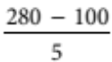 [1 mark]
= 36 kPa/s [1 mark]
[2 marks]
2 Temperature at 1 minute = 70 °C [1 mark]
Temperature at 4 minutes = 35 °C [1 mark]
Rate of temperature change = 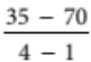 [1 mark]
 11.67 °C/minute [1 mark]
[4 marks]
3 Draw in a tangent at 3 minutes.
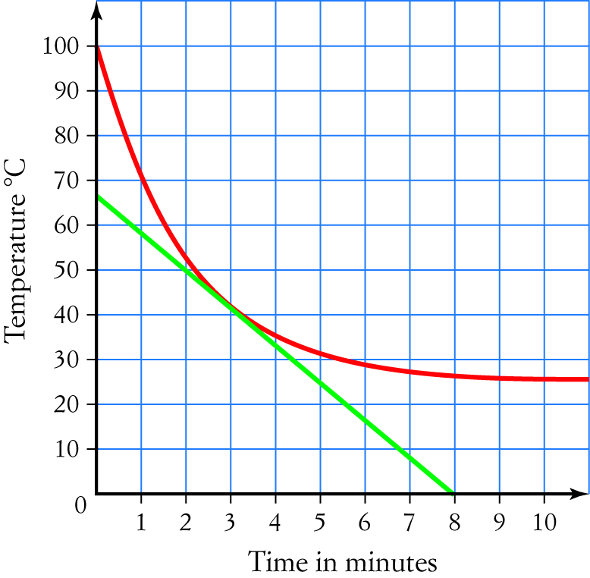
[2 marks for reasonably accurate tangent]
The tangent goes through (0, 67) and (8, 0). [1 mark each]
Rate of change of temperature = 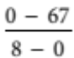 [1 mark]
 −8.4 °C/minute [1 mark for figure, 1 for units]
[7 marks]
4 Enter the function as a graph. [1 mark]
Use trace and zoom-in to put a point at (3, 1.6). [1 mark]
Draw a tangent and measure the slope to get −0.72. [2 marks]
[4 marks]
5 Calculate the values at 2.98 and 3.02 to get (2.98, 2.0796) and (3.02, 1.9196). [1 mark each]
Then δy = 1.9196 − 2.0796 = −0.16 [1 mark]
So the gradient is 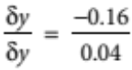 [1 mark]
= (approximately) −4 [1 mark]
[5 marks]
Part C
Students are expected to use CAS calculators efficiently.
1 At x = 0, the approximate rate of change is −4. [1 mark]
At x = 1, the approximate rate of change is 2. [1 mark]
At x = 2, the approximate rate of change is 8. [1 mark]
At x = 3, the approximate rate of change is 14. [1 mark]
At x = 4, the approximate rate of change is 20. [1 mark]
This suggests that the function for the rate of change is y = 6x − 4. [2 marks]
[7 marks]
2 a At x = 0, the approximate rate of change is 3. [1 mark]
At x = 2, the approximate rate of change is 1200. [1 mark]
At x = 3, the approximate rate of change is 2400. [1 mark]
b The values of f (x) at 0, 2 and 3 are 1, 400 and 8000. [1 mark]
The ratios of the rates of change to the values are all the same
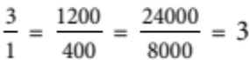 [1 mark]
This suggests that the function for the rate of change is y = 3 × 20x [2 marks]
[7 marks]

